Refresh:

A Strategy Pattern says that "defines a family of functionality, encapsulate each one, and make them interchangeable".

The Strategy Pattern is also known as Policy.

Use it:

* When the multiple classes differ only in their behaviorse.g. Servlet API.
* It is used when you need different variations of an algorithm.

Exercise:

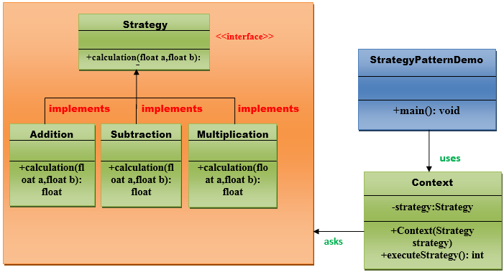

With the above diagram check our StrategyExercise.zip and add the classes that are missing to get the next output:

Check the complete solution at:

[Strategy Pattern - Javatpoint](https://www.javatpoint.com/strategy-pattern)